# MAJOR PROJECT REPORT

## On

FAKE NEWS DETECTION

## Submitted in Partial fulfillment for the Award of the degree of Bachelor of Technology

**In**

**INFORMATION TECHNOLOGY**

**Submitted to**

**RAJIV GANDHI PROUDYOGIKI VISHWAVIDHYALAYA, BHOPAL (M.P)**



**Submitted by**

### AKRSH MATHUR (0126IT 181003)

**HARSHIT JAIN (0126 IT181026)**

**HIMANSHU PATEL (0126IT181027)**

**KUNAL SAHU ( 0126IT 181035 )**

**Under the IT guidance of Joy Bhattacharjee**

Prof.

# ORIENTAL COLLEGE OF TECHNOLOGY, BHOPAL

## Department of Information Technology Engineering

Approved by AICTE New Delhi & Govt. of MP

Affiliated to Rajiv Gandhi Proudyogiki Vishwavidyalaya, Bhopal

Phone No.-0755-2529015, 2529016

Fax: 0755-2529472

E-mail: [directoroct@oriental.ac.in](mailto:directoroct@oriental.ac.in)

Website: <http://www.oriental.ac.in/oct-bhopal/>



# ORIENTAL COLLEGE OF TECHNOLOGY, BHOPAL

Approved by AICTE, New Delhi & Govt. of M.P. Affiliated to Rajiv Gandhi Proudyogiki Vishwavidyalaya, Bhopal Oriental Campus, Raisen Road, Bhopal-462021 (MP) INDIA

## DEPARTMENT OF INFORMATION TECHNOLOGY ENGINEERING CANDIDATE’S DECLARATION

I hereby declare that the Minor/ Major Project report on “ Fake News Detection” which is being presented here for the partial fulfillment of the requirement of Degree of *“ Bachelor of Technology”* has been carried out at Department of Information Technology Engg. Oriental College of Technology Bhopal. The technical information provided in this report is presented with due permission of the authorities from the training organization.

Signature of Student

### AKRSH MATHUR (0126IT 181003 )

**HARSHIT JAIN ( 0126IT181026)**

**HIMANSHU PATEL ( 0126IT181027)**

**KUNAL SAHU ( 0126 IT181035)**



**ORIENTAL COLLEGE OF TECHNOLOGY, BHOPAL**

Approved by AICTE, New Delhi & Govt. of M.P. Affiliated to Rajiv Gandhi Proudyogiki Vishwavidyalaya, Bhopal Oriental Campus, Raisen Road, Bhopal-462021 (MP) INDIA

## DEPARTMENT OF INFORMATION TECHNOLOGY ENGINEERING

**CERIFICATE OF INSTITUTE**

### This is to certify that Mr. AKRSH MATHUR (0126 IT181003), HARSHIT JAIN ( 0126 IT 181026), HIMANSHU PATEL (0126 IT181027 ), KUNAL SAHU

**( 0126 IT 181035) of B. Tech Information Technology Department has successfully completed his Major Project during the academic year 2021-2022 as partial fulfillment of the Bachelor of Technology in Information Technology Engineering.**

**Name of Faculty Coordinator :Joy Bhattacharjee Name of HOD : Amit Kanskar**

Designation **: Prof.** HOD **:** Department Of Information Technology

# ACKNOWLEDGEMENT

I take the opportunity to express my cordial gratitude and deep sense of indebtedness to my guide for the valuable guidance and inspiration throughout the project duration. I feel thankful to him for his innovative ideas, which led to successful submission of this minor project work. I feel proud and fortune to work under such an outstanding mentor in the field of **Fake News Detection** He has always welcomed my problem and helped me to clear my doubt. I will always be grateful to him for providing me moral support and sufficient time.

At the same time, I would like to thank and all other faculty members and all non-teaching staff of department of Computer Science &Engineering for their valuable co-operation.

I owe sincere thanks to Director OIST, for providing me with moral support and necessary help during my project work in the Department.

I would also thank to my Institution, faculty members and staff without whom this project would have been a distant reality. I also extend my heartfelt thanks to my family and well- wishers.

### AKRSH MATHUR (0126IT181003 )

**HARSHIT JAIN ( 0126IT 181026)**

**HIMANSHU PATEL (0126IT181027 )**

**KUNAL SAHU (0126 IT181035)**

**ABSTRACT**

In our modern era where the internet is ubiquitous, everyone relies on various online resources for news. Along with the increase in the use of social media platforms like Facebook, Twitter, etc. news spread rapidly among millions of users within a very short span of time. The spread of fake news has far-reaching consequences like the creation of biased opinions to swaying election outcomes for the benefit of certain candidates. Moreover, spammers use appealing news headlines to generate revenue using advertisements via click-baits. In this paper, we aim to perform binary classification of various news articles available online with the help of concepts pertaining to Artificial Intelligence, Natural Language Processing and Machine Learning. We aim to provide the user with the ability to classify the news as fake or real and also check the authenticity of the website publishing the news.

**TABLE OF CONTENTS**

List of Figures

### INTRODUCTION

* 1. Introduction
  2. Aim and Objectives
  3. Motivation
  4. Scope of Project

### LITERATURE SURVEY

* 1. Introduction
  2. Existing System
  3. Need of New System
  4. Problem Definition

### DESIGN AND IMPLEMENTATION

* 1. Proposed System
  2. Design
     1. Website Design
     2. System Architecture Diagram
     3. System Design Diagram
  3. Methodology used

### CONCLUSION

* 1. Summary
  2. Future Scope

### REFERENCES

1. **INTRODUCTION**

As an increasing amount of our lives is spent interacting online through social media platforms, more and more people tend to hunt out and consume news from social media instead of traditional news organizations.[1] The explanations for this alteration in consumption behaviours are inherent within the nature of those social media platforms: (i) it's often more timely and fewer expensive to consume news on social media compared with traditional journalism , like newspapers or television; and (ii) it's easier to further share, discuss , and discuss the news with friends or other readers on social media. For instance, 62 percent of U.S. adults get news on social media in 2016, while in 2012; only 49 percent reported seeing news on social media [1]. It had been also found that social media now outperforms television because the major news source. Despite the benefits provided by social media, the standard of stories on social media is less than traditional news organizations. However, because it's inexpensive to supply news online and far faster and easier to propagate through social media, large volumes of faux news, i.e., those news articles with intentionally false information, are produced online for a spread of purposes, like financial and political gain. it had been estimated that over 1 million tweets are associated with fake news “Pizzagate" by the top of the presidential election. Given the prevalence of this new phenomenon, “Fake news" was even named the word of the year by the Macquarie dictionary in 2016 [2]. The extensive spread of faux news can have a significant negative impact on individuals and society. First, fake news can shatter the authenticity equilibrium of the news ecosystem for instance; it's evident that the most popular fake news was even more outspread on Facebook than the most accepted genuine mainstream news during the U.S. 2016 presidential election. Second, fake news intentionally persuades consumers to simply accept biased or false beliefs. Fake news is typically manipulated by propagandists to convey political messages or influence for instance, some report shows that Russia has created fake accounts and social bots to spread false stories. Third, fake news changes the way people interpret and answer real news, for instance, some fake news was just created to trigger people's distrust and make them confused; impeding their abilities to differentiate what's true from what's not. To assist mitigate the negative effects caused by fake news (both to profit the general public and therefore the news ecosystem). It's crucial that we build up methods to automatically detect fake news broadcast on social media [3]. Internet and social media have made the access to the news information much easier and comfortable [2]. Often Internet users can pursue the events of their concern in online form, and increased

number of the mobile devices makes this process even easier. But with great possibilities come great challenges. Mass media have an enormous influence on the society, and because it often happens, there's someone who wants to require advantage of this fact. Sometimes to realize some goals mass-media may manipulate the knowledge in several ways. This result in

producing of the news articles that isn’t completely true or maybe completely false. There even exist many websites that produce fake news almost exclusively 1.2 Aim and Objectives The main objective behind the development and upgradation of existing projects are the following smart approaches: • Be Aware of such article while forwarding to others • Reveal True stories

* Prevent from false crisis events • Be Informative 1.3 Motivation Machine learning (ML) is a type of artificial intelligence (AI) that allows software applications to become more accurate at predicting outcomes without being explicitly programmed to do so. Machine learning algorithms use historical data as input to predict new output values. The extensive spread of faux news can have a significant negative impact on individuals and society. First, fake news can shatter the authenticity equilibrium of the news ecosystem for instance. Understanding the truth of new and message with news detection can create positive impact on the society. 1.4 Scope The usage of this system greatly reduces the time required to search for a place leading to quicker decision making with respect to places to visit. Used to view the location view (the user can even zoom in and zoom out to get a better view) as well as 360 degree image embedded in the application. The System makes use of weather underground API for fetching the details of weather at accuracy.

## Aim and Objectives :

The main objective behind the development and upgradation of existing projects are the following smart approaches:

* + - Be Aware of such article while forwarding to others
    - Reveal True stories
    - Prevent from false crisis events

**.** Be Informative

## Motivation :

Machine learning (ML) is a type of artificial intelligence (AI) that allows software applications to become more accurate at predicting outcomes without being explicitly programmed to do so. Machine learning algorithms use historical data as input to predict new output values.

The extensive spread of faux news can have a significant negative impact on individuals and society. First, fake news can shatter the authenticity equilibrium of the news ecosystem for instance.

Understanding the truth of new and message with news detection can create positive impact on the society.

## Scope :

The usage of this system greatly reduces the time required to search for a place leading to quicker decision making with respect to places to visit. Used to view the location view (the user can even zoom in and zoom out to get a better view) as well as 360 degree image embedded in the application. The System makes use of weather underground API for fetching the details of weather at accuracy.

The user can also find the paths to follow to reach the final destination in map which gives a better view to the users. It becomes convenient for users to book their tour via website instead of visiting agency ultimately saves time and money.

# LITERATURE SURVEY

## Introduction :

Our project is an web application which gives you the guidance of the day to day rountine of fake news, spam message in daily news chanel , Facebook, Twitter, Instagram and other social media.We have shown some data analysis from our dataset which have retrive from many online social media and display the main source till now fake news and true news are engaged. Our project is tangled with multiple model trained by our own and also some pretrained model extracted from Felipe Adachi. The accuracy of the model is around 95% for all the selfmade model and 97% for this pretrained model. This model can detect all news and message which are related to covid-19,political news, geology ,etc.

## Existing System :

We can get online news from different sources like social media websites, search engine, homepage of news agency websites or the factchecking websites. On the Internet, there are a few publicly available datasets for Fake news classification like Buzzfeed News, LIAR [15], BS Detector etc. These datasets have been widely used in different research papers for determining the veracity of news. In the following sections, I have discussed in brief about the sources of the dataset used in this work.This Existing system can help us to trained our model using machine learning technique.

## Need of New System :

Currently, many people are using the internet as a central platform to find the information about reality in world and need to be continue.Hence I has mention above we will create fake news and message detection model which detect the reality of the news and message.

Also whose use our website can see the upto date about main source or keyword are getting most fake news and message and mapoed up with chart. After and all everyone want to know how to prevent this hence we are giving some important tips to avoid this fake news of spreading rumor in the world.

## Problems Definition :

The system is an Web application which help user to detect the fake news. We have given the text box where the user has the option to paste the message or paste the url link of the news and other message link and after that it gives the reality of it. All the user gives data to detector may save for further use in order to update the statue of model, data analysis in future. We also help user by giving some guidance of how to prevent from such false event and how to stop with such event from spreading it.

# DESIGN AND IMPLEMENTATION

## Proposed system :

The system is a Web application which help user to detect the fake news. We have given the text box where the user has the option to paste the message or paste the url link of the news and other message link and after that it gives the reality of it. All the user gives data to detector may save for further use in order to update the statue of model, data analysis in future. We also help user by giving some guidance of how to prevent from such false event and how to stop with such event from spreading it.

## Design :



**System Architecture Design :**

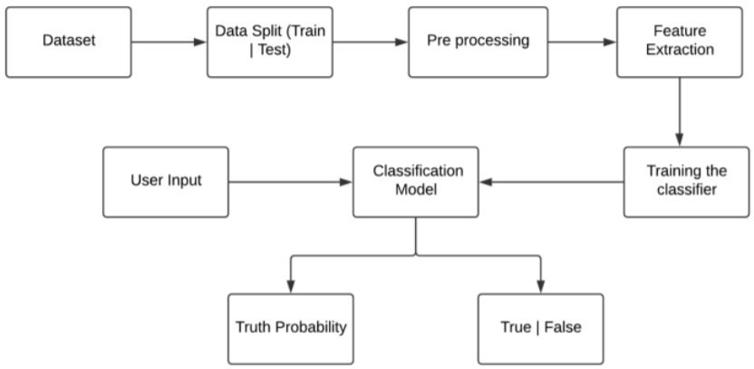

**System Design Diagram :**

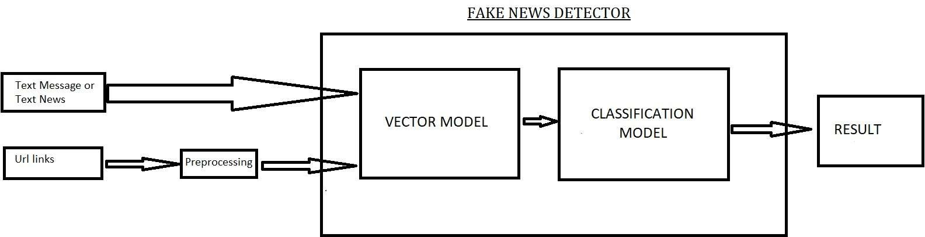

**Methodology used :**

### Random Forest Classifier :

Random Forest is a trademark term for an ensemble of decision trees. In Random

Forest, we’ve collection of decision trees (so known as “Forest”). To classify a new object based on attributes, each tree gives a classification and we say the tree “votes” for that class. The forest chooses the classification having the most votes (over all the trees in the forest). The random forest is a classification algorithm consisting of many decisions trees. It uses bagging and feature randomness when building each individual tree to try to create an uncorrelated forest of trees whose prediction by committee is more accurate than that of any individual tree. Random forest, like its name implies, consists of a large number of individual decision trees that operate as an ensemble. Each individual tree in the random

forest spits out a class prediction and the class with the most votes becomes our model’s prediction. The reason that the random forest model works so well is: A large number of relatively uncorrelated models (trees) operating as a committee will outperform any of the individual constituent models.

### Passive Aggressive Classifier Algorithm :

Passive-Aggressive algorithms are generally used for large-scale learning. It is one of the few ‘**online-learning algorithms**‘. In online machine learning algorithms, the input data comes in sequential order and the machine learning model is updated step-by-step, as opposed to batch learning, where the entire training dataset is used at once. This is very useful in situations where there is a huge amount of data and it is computationally infeasible to train the entire dataset because of the sheer size of the data. We can simply say that an online-learning algorithm will get a training example, update the classifier, and then throw away the example.

# CONCLUSION

## Summary :

With the help of Machine Learning we have create 5 prediction model which gives the accuracy above 90% and it cover all latest political covid 19 news .Also with some pretrained model we have cover news related to history and sport.

We intent to build our own dataset which will be kept up to data according to the latest news in future.

## Future Scope :

This project can be further enhanced to provide greater flexibility and performance with certain modification whenever necessary.

Deep fake learning which can be help to detect fake image . Deep learning machine learning to get more accurate result

# REFERENCES

### Websites: https://github.com/Kotlin/dokka

**https://**[**www.tensorflow.org/lite/guide/android**](http://www.tensorflow.org/lite/guide/android)

**https://**[**www.tensorflow.org/lite/inference_with_metadata/task_library/overview**](http://www.tensorflow.org/lite/inference_with_metadata/task_library/overview)

**https://**[**www.kaggle.com/clmentbisaillon/fake-and-real-news-dataset**](http://www.kaggle.com/clmentbisaillon/fake-and-real-news-dataset)

1. Kai Shu, Amy Sliva, Suhang Wang, Jiliang Tang, and Huan Liu, “Fake News Detection on Social Media: A Data Mining Perspective” arXiv:1708.01967v3 [cs.SI], 3 Sep 2017
2. M. Granik and V. Mesyura, "Fake news detection using naive Bayes classifier," 2017 IEEE First Ukraine Conference on Electrical and Computer Engineering (UKRCON), Kiev, 2017, pp. 900-903.
3. Fake news websites. (n.d.) Wikipedia. [Online]. Available: https://en.wikipedia.org/wiki/Fake_news_website. Accessed Feb. 6, 2017
4. Cade Metz. (2016, Dec. 16). The bittersweet sweepstakes to build an AI that destroys fake news.
5. Conroy, N., Rubin, V. and Chen, Y. (2015). “Automatic deception detection: Methods for finding fake news” at Proceedings of the Association for Information Science and Technology, 52(1), pp.1-4.